Magic counting card trick
https://www.youtube.com/watch?v=SfT8AJbo8C4
In this movie there are 3 card tricks. If you watch the movie the first time, I don’t think you get how they work. But after thinking about the tricks we came to the conclusion that there’s math in almost all these tricks. Now we are going to explain the math and magic behind these tricks.

Trick 1
In the first trick you’re asked to pick a card without telling which one you picked. Then the magician takes one card away from the five. Then he shows the four cards that are left and asks you if your card disappeared. Not surprisingly, it is gone!
But how?
This trick doesn’t involve math but for the people that’re interested; I will shortly explain how it works. Since this is ‘a movie trick’, this trick works very easy; the cards you get to pick from are all different cards, than the cards that are shown afterwards. So your card always disappeared.
Before taking a card away
After taking a card away

Trick 2
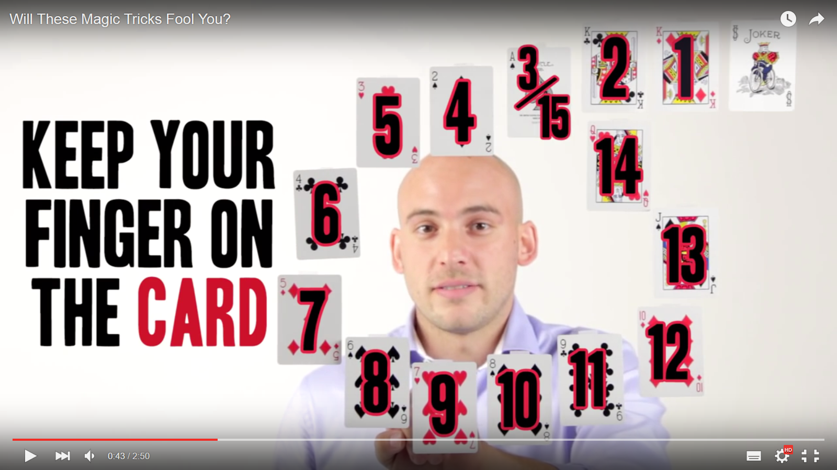
In the second trick you’re asked to pick a number between 5 and 15. Let’s say we choose 9. After you’ve chosen a number you should start counting from the card next to the joker to your number which is in our case 9. Like this;

So we’re at the 7 of hearts. Than we’re asked to count from our secret card clockwise 9 cards
(because that was our secret number). So now we’re here.

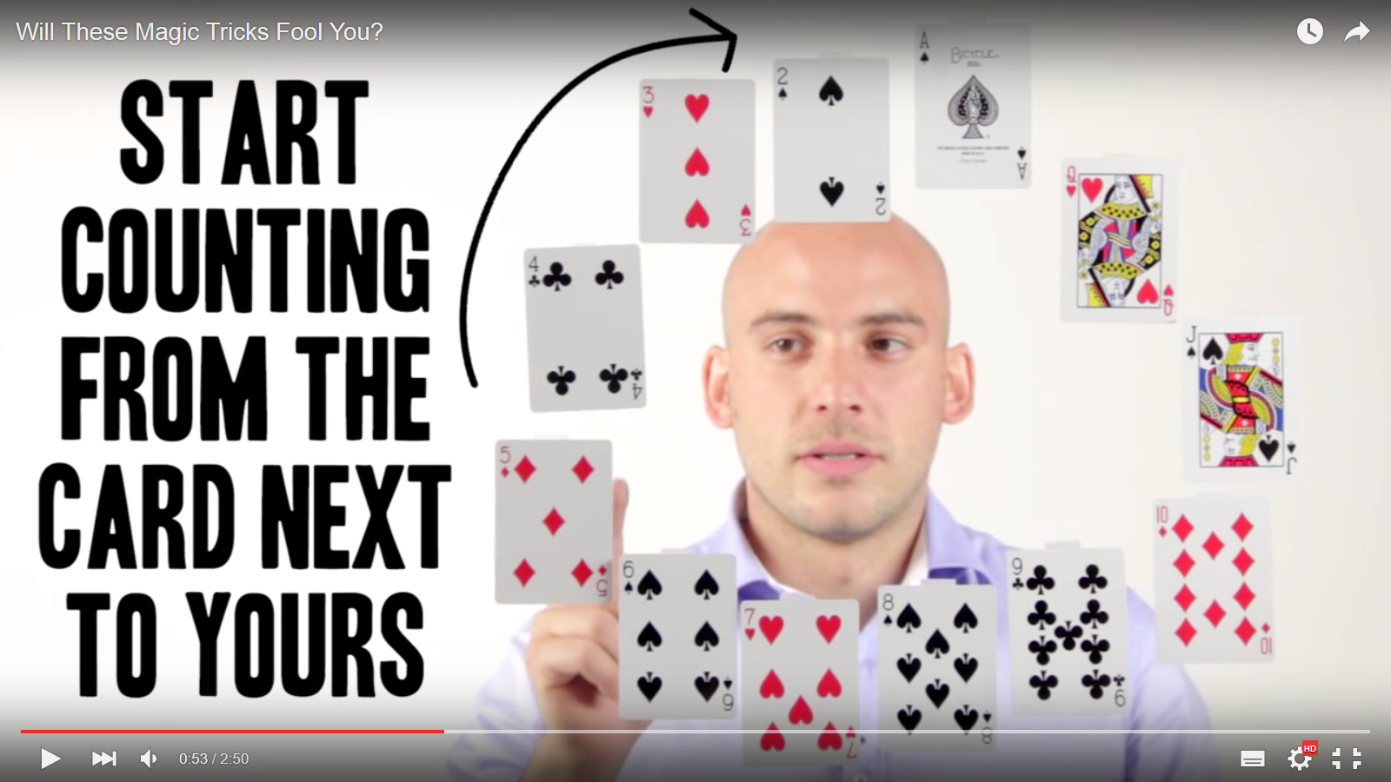

Then some cards are taken away. Like this:

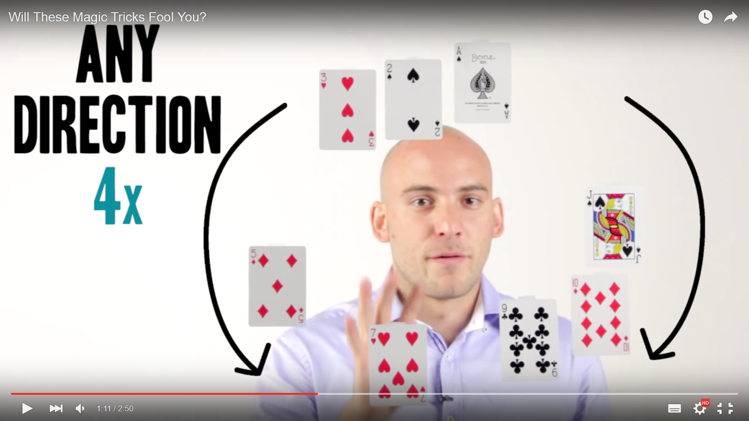
Now we’re asked to count 4 cards in any direction from our secret card. So we end up over here.
And of course this is guessed by the magician. Incredible isn’t it?

But how does it work?
If you try this trick a few times you’ll recognize that whatever number you pick you’ll always end up at the 3 of hearts. This trick does involve math, as you might have expected.
So first you choose a number between 5 and 15 and you count to that card counterclockwise (like in step 1 described above). Then the next step is counting from the card next to yours the same amount as your secret number in clockwise direction. This might look special but if you look closely you see that you just count back; like when you do 15 and then you count 15 in the opposite direction it will result in 0. In a sum this would be 15-15=0. If you look at image 1 you see that 0 is at the joker. But since the first three cards have been removed in this second step the 10 of diamonds becomes ‘the zero’. So whatever number you pick you’ll always end up at ‘the zero’ which is the 10 of diamonds. Then some cards are removed. You’re asked to count four cards in any direction, but since you always end up at the 10 of diamonds, after this step you’ll always end up at the 3 of hearts. This is because if you look at the picture above you’ll see that there are three cards between the 10 of diamonds and the 3 of hearts, so if you count four in any direction you’ll always get on the three of hearts.
So this is how it works!

Trick 3
In the third trick you will guess what the magician has in his hands. The first thing you have to do is think of your age. After having done this (which isn’t very difficult we expect) you add the two numbers of your age. When your age is less than 10 you should simply add 10 to your age. So when your age is 44 you add 4 and 4 which results in 8. When your age is 8 you should add 10 which results in 18 then you add again 1 and 8 which results in 9. Let’s assume your age is 15 than you add 1 and 5 which is 6. The next step is to subtract this number from your age. So in our case this is 15-6=9. Then a whole list of numbers is shown to you and you’re asked to look at the word standing behind your number. We see that behind our number 9 the word coins is written and when the magician shows what he has in his hands it appears to be right; you’ve guessed what the magician has in his hand!

But how where you able to do this?
This trick appears to work for every age; you’ll always get the right answer. The trick is that for every ten years of age another number will be the outcome;
- Age between 0 and 19 (also including 19) always end up in 9;
For example
18-(8+1)=9
15-(5+1)=9
- Age between 20 and 29 always end up in 18:
For example
23-(2+3)=18
21-(2+1)=18
- Age between 30 and 39 always end up 27:
For example
33-(3+3)=27
37-(3+7)=27
- Age between 40 and 49 always ends up to be 36:
For example
45-(4+5)=36
47-(4+7)=36
- Age between 50 and 59 always ends up to be 45
- Age between 60 and 69 always end up to be 54
- Age between 70 and 79 always end up to be 63
- Age between 80 and 89 always end up to be 72
- Age between 90 and 99 always end up to be 81
But now there’s another question if all these outcomes are different for each ten years of age why is the outcome always right?
These are the words written behind the numbers which could be the outcome:
9. coins
18. money
27. quarters
36. change
45. currency
54. coins
63. change
72. quarters
81. currency
You see that these words all fit with the coins in the magicians’ hand.

But why do all ages between 20 and 29 result in 18?
This is because you subtract both numbers from your age. With this I mean that you for example do 23-(2+3). Mathematically spoken 23-(2+3) = 23-2-3. The last number you subtract is the number which makes the number different from all the other numbers in the 20s. So in this case the 3 is subtracted to make the number 20. Then the number 2 is fixed for all the numbers in the 20s so it always ends up to be 18. The formula for this is 18=x-y-q. Where x is your age, y is your second number of your age (so the number that makes your number different from the other numbers in the 20s) and where the q stands for the first number of your age but you can also say that this number is a fixed number for every ten years of age so for 10 to 19 the fixed number is 1, from number 20 to 29 the fixed number is 2 and so on.

You can do the same for all the ten years of age:
27=x-y-q
27=x-2-q
Where x is your age and q is the second number of your age
The same for ages from 60-69
54=x-y-q
54=x-5-q
Where x is your age and q is the second number of your age
And so on and so on

We hope you now understand the math behind these tricks and hope you enjoyed it!

