How to choose the best formation for a football match:

A coach has to put his team in a proper formation, in order to win a match. But what is the best formation for which team? Football knows thousands of formations, which are all different. We will be breaking down some of these formations.

- 4-4-2
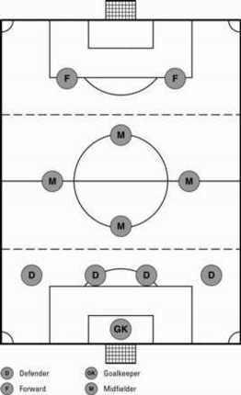
With this formation, there are four defenders, two central defenders and two backs. Those two backs will go to the front when the team is attacking.
There are four midfielders, one who is more defensive, and one who is more offensive. The two other midfielders are not situated in between the centre and the side of the field. If they would be situated more to the side, there would be a gap in the centre of the midfield, which can lead to a disadvantage.
The two strikers are situated central, because if the defence of the other team has the ball, one can try to take the ball while the other blocks the path of a possible pass.
This formation makes use of the back as wingers to get more offensive power. The only disadvantage is that it is vulnerable for counter-attacks, so the team has to have some fast players to defend a counter-attack .

- 4-3-3
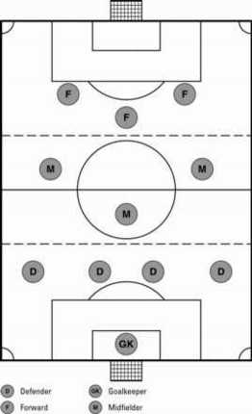
The defence of this formation is the same as the 4-4-2 formation, the only difference is that the backs won’t go forward as much.
There is one defensive midfielder in this formation and two regular midfielders. These three players are situated more to the front compared to the 4-4-2 formation. The midfielders must be a pretty good header because most goal-kicks will get to them
There are two wingers (most likely fast or technical) and one central striker (mostly strong and a good header) in the offence. The wingers are supposed to run at the outer part of the field and give a cross to the striker. Those wingers should also help the defence when the other team is attacking, so then the formation looks like 4-5-1.
There is another variant of this formation where the defensive midfielder and the striker are situated more to the front to make this formation even more attacking.

- 4-2-4
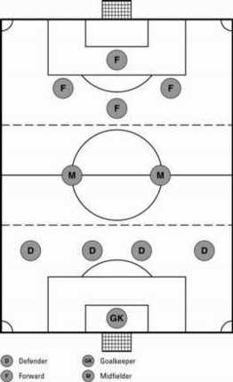
With this formation there are four midfielders as well.
The midfield is only made up of two players who have to constantly move forward and backwards because if the opponent team is attacking, they have to defend and when their team is attacking the have to help with that attack.
The four attackers often wait for the midfielders to arrive in the offence before they try to score or they try to score immediately.
This formation isn’t used much in football nowadays and the only team which was successful with this formation was Brazil in 1958.
When a team uses this formation their defence has to be solid and the midfield has to have a very good endurance. The attackers often change their position to confuse the opponent’s defence

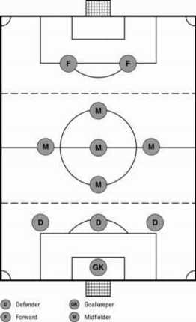
- 3-5-2

This formation makes use of three defenders because there are many midfielders who help the defence when they aren’t in possession.
Five midfielders are in this formation, they have to be fit and creative in order to make this formation work. The two wingers have both an attacking and defending role. When in an offence, one of the wingers can cross the ball in the box ( the largest rectangle in front of the goal) and the 2 strikers, one midfielder and the other winger can try to head the ball in the goal. The other five player must stay defensively so when the attack fails they can intercept the ball.
The two strikers are mostly used to head the ball but sometimes to make a dribble towards the goal.
This formation is used because most matches are won on the midfield; If possession is kept on the midfield, more opportunities to score can be created

What team a coach has to choose depends on what kind of players the team has. If he has many, creative midfielders he can try the 3-5-2 formation or the 4-4-2. A formation combined with a proper tactic, can lead to a victory.

